**Practical -6**

**Aim - Implementation of Sharding in MongoDB.**

**STEP 1**

Create config folder in C Drive.Inside that create three folders c1,c2,c3.

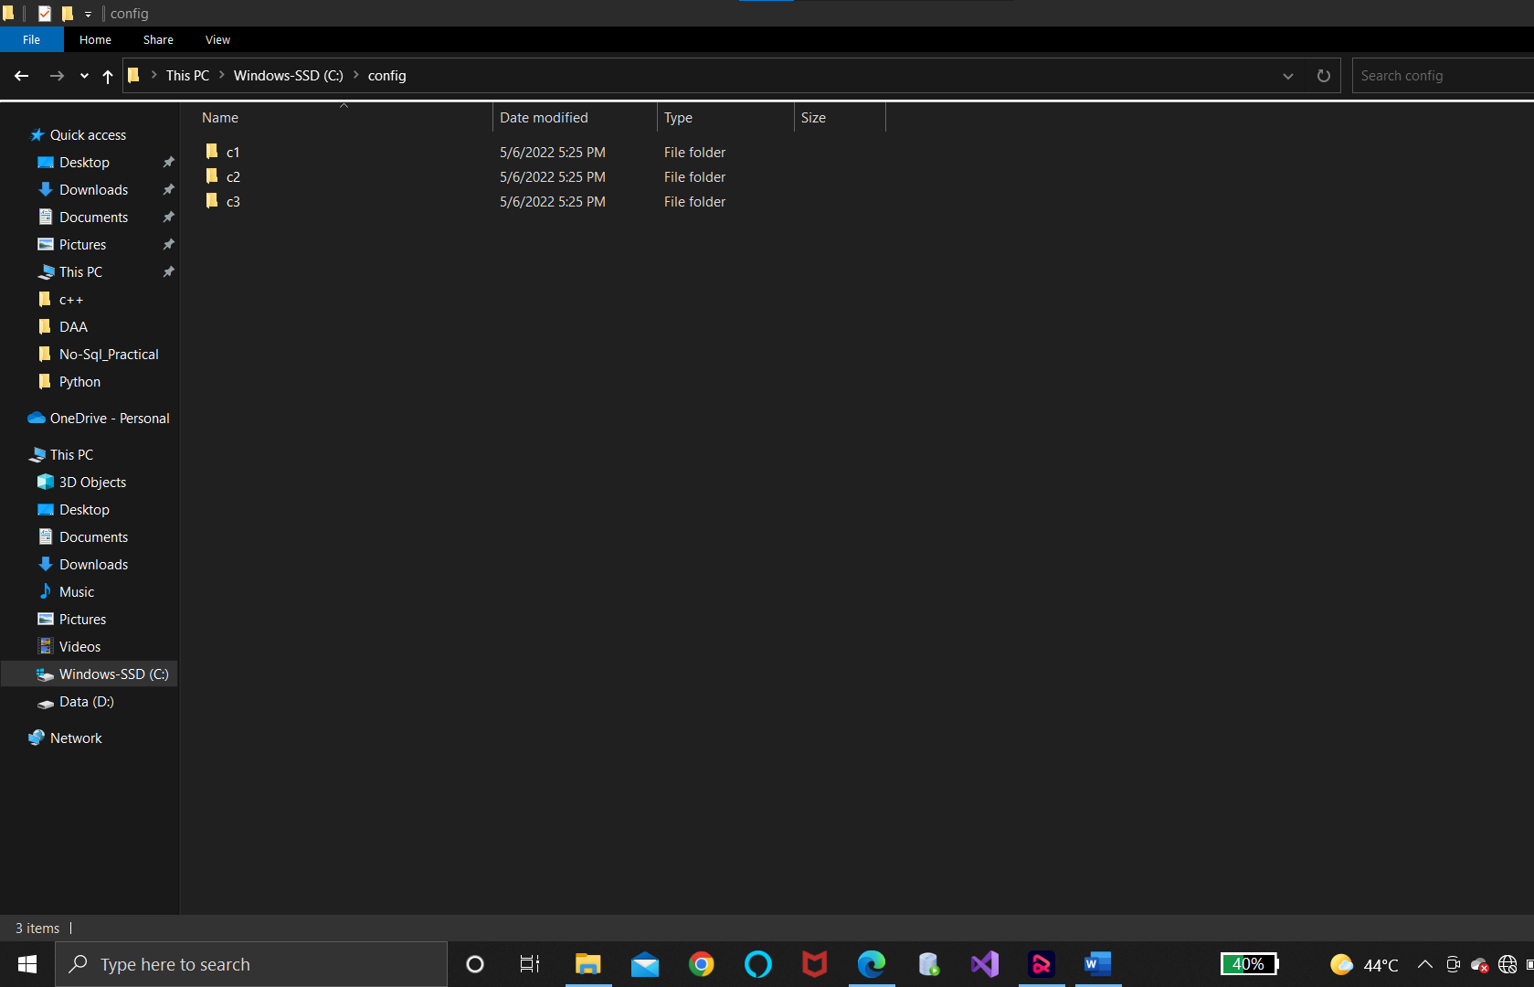

**STEP 2**

Create shard1 folder in drive. Inside that create three sub folders s1,s2,s3.

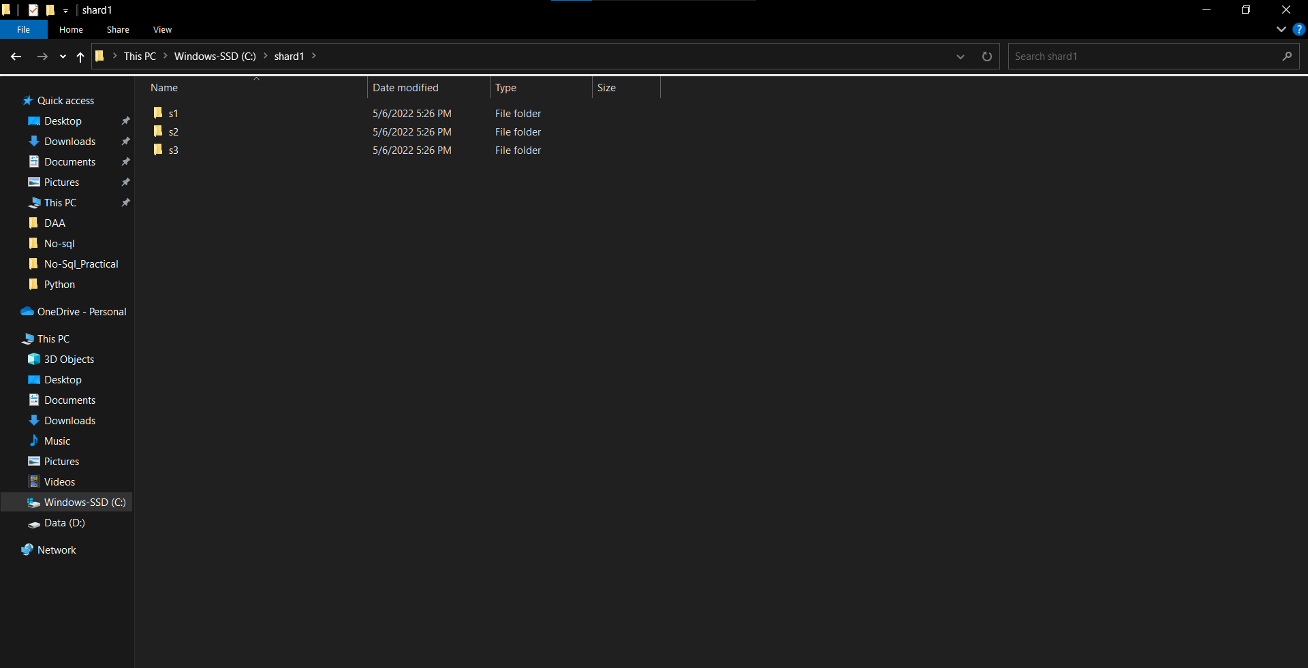

**STEP 3**

Create shard2 folder in drive. Inside that create three sub folders s1,s2,s3.

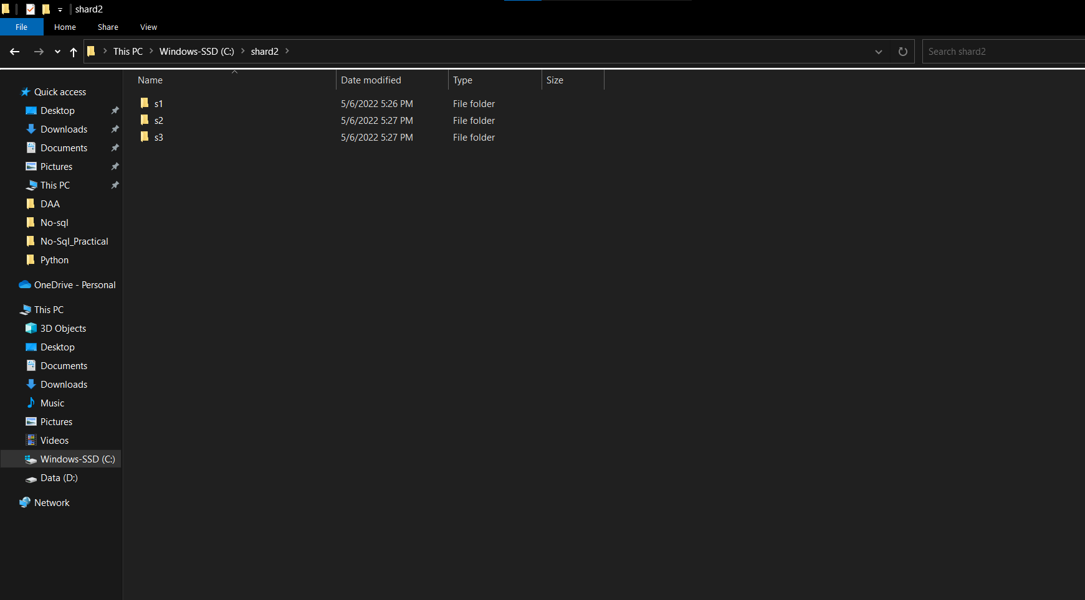

**STEP 4**

OPEN command Prompt.

Create three Config Server. Then Set one Config Server as Primary and remaining two as secondary.

*Using below commands.*

C:\Program Files\MongoDB\Server\4.2\bin>mongod --configsvr --dbpath "C:\config\c1" --port 27018 --replSet=c0

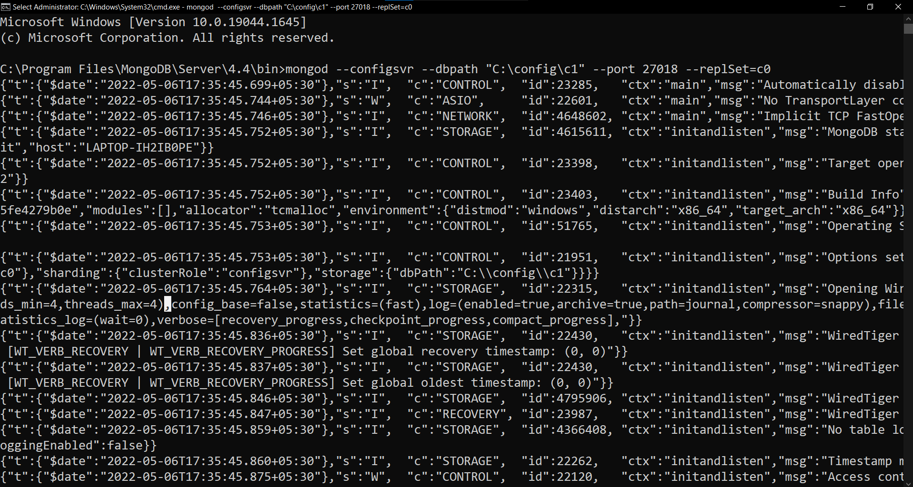

C:\Program Files\MongoDB\Server\4.2\bin>mongod --configsvr --dbpath "C:\config\c2" --port 27019

--replSet=c0

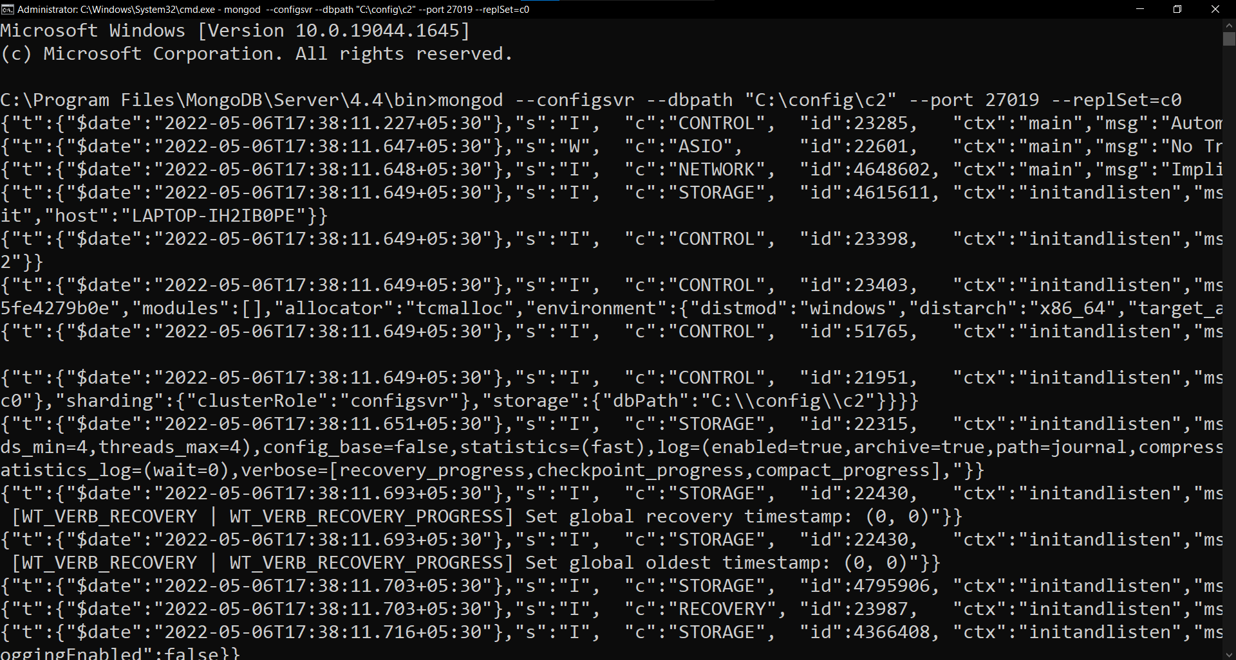

C:\Program Files\MongoDB\Server\4.2\bin>mongod --configsvr --dbpath "C:\config\c3" --port 27020

--replSet=c0

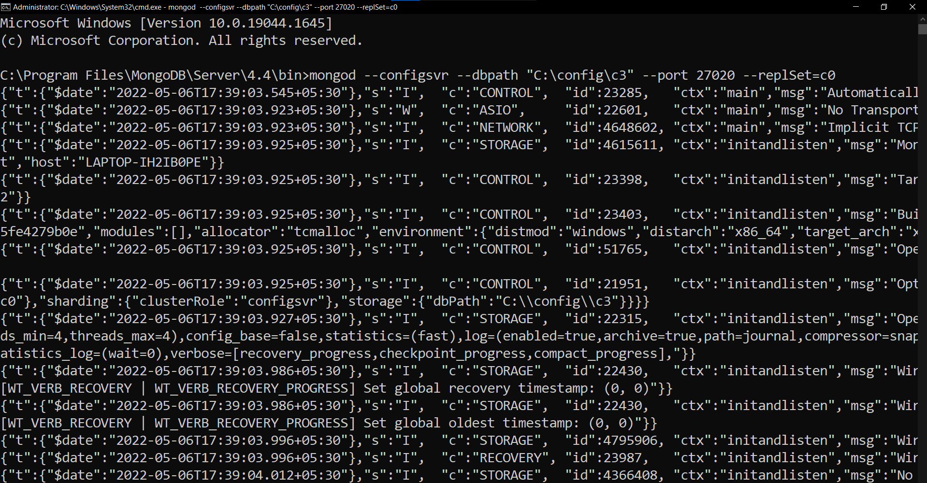

**Now open any mongo client among all and connect with server using below command.**

C:\>mongo --port 27019

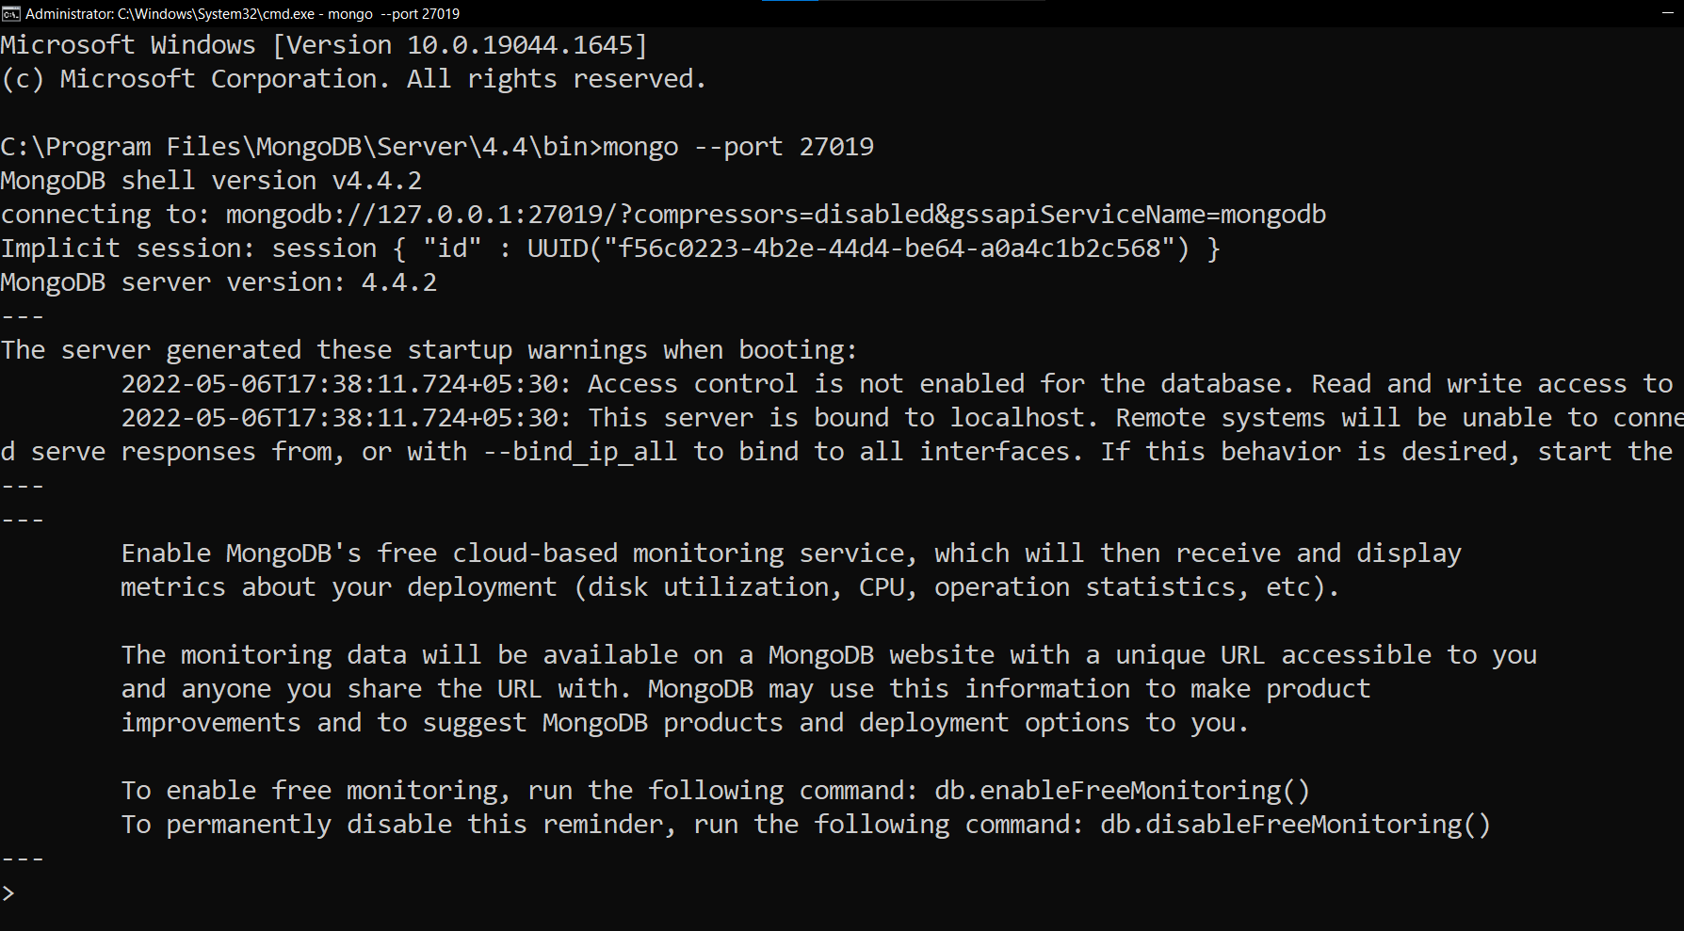

Create a group ,assign ids and replica using below command.

config = { _id: "c0", members:[

{ _id : 0, host : "localhost:27018" }, { _id : 1, host : "localhost:27019" },

{ _id : 2, host : "localhost:27020" }]};

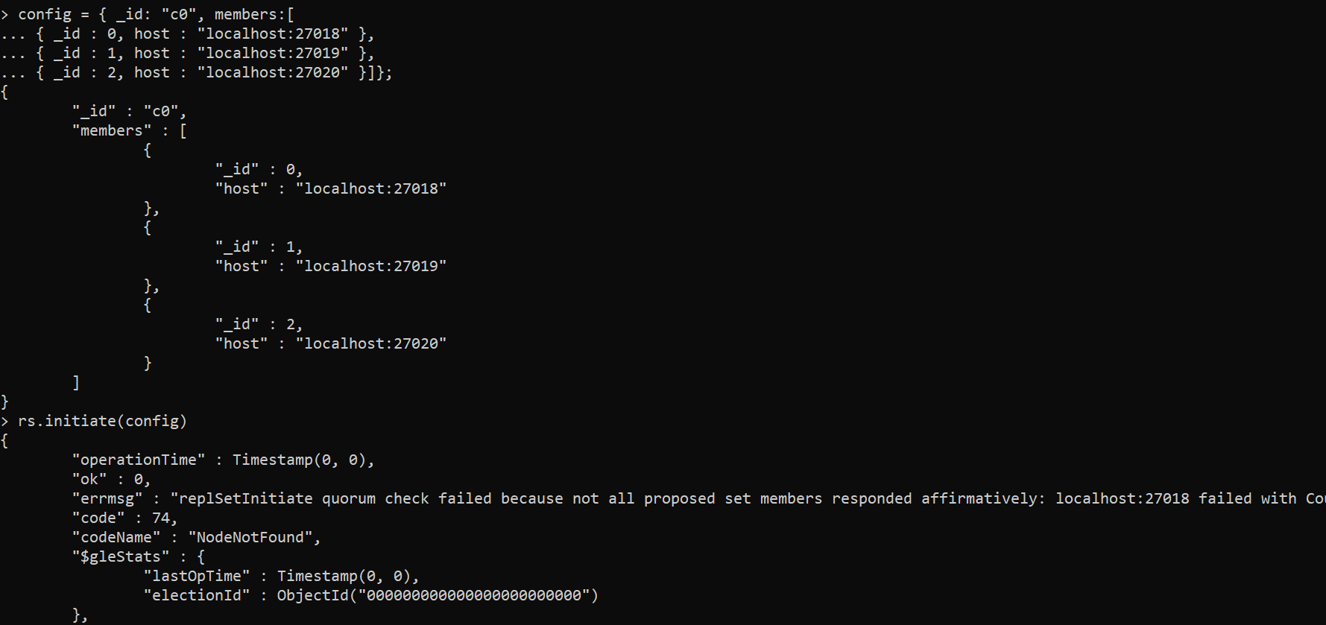

**Set any node as primary node using below given command.**

rs.initiate(config)

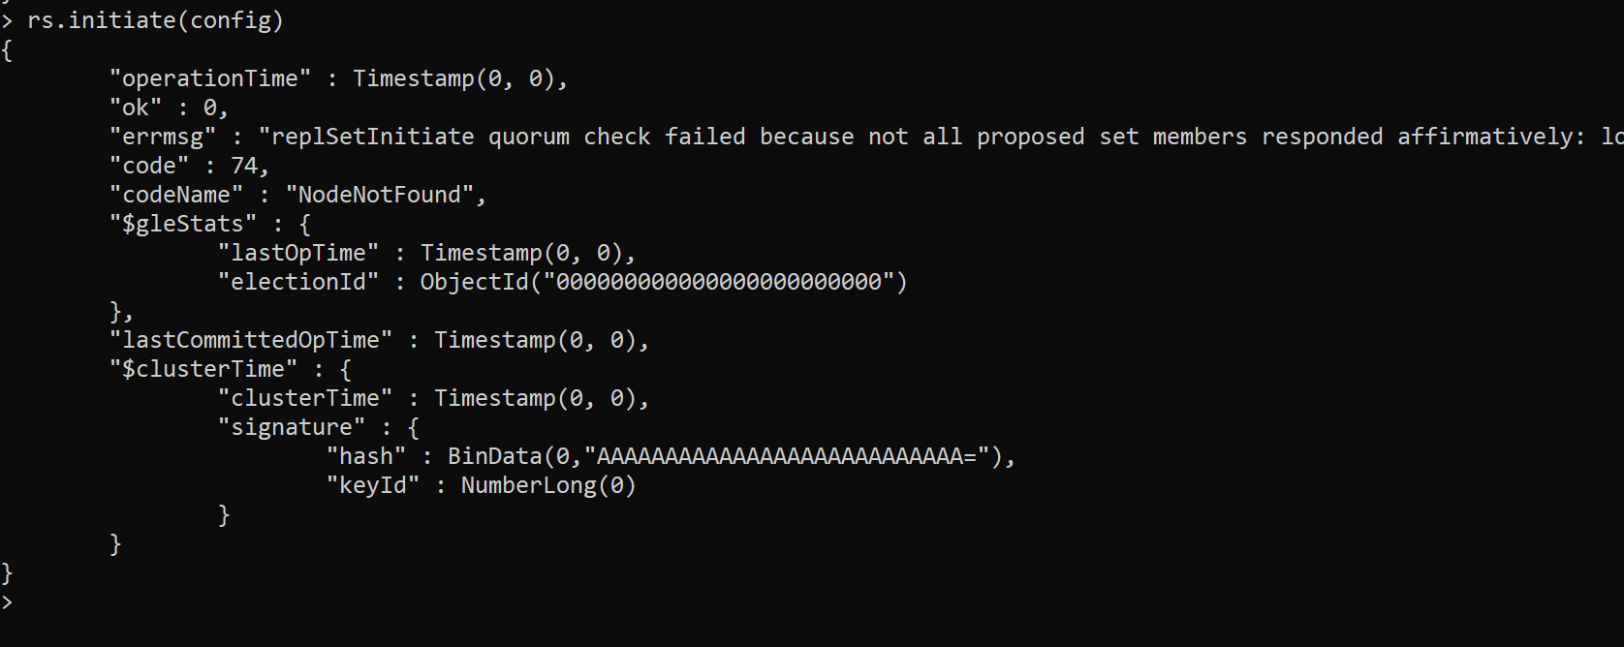

**STEP 5 (SHARD 1)**

**OPEN command Prompt.**

**Create three Shard Server. Then Set one shard Server as Primary and remaining two as secondary. *Using below commands.***

C:\Program Files\MongoDB\Server\4.2\bin>mongod --replSet s1 -- dbpath "C:\shard2\s1" --port 37019 --shardsvr

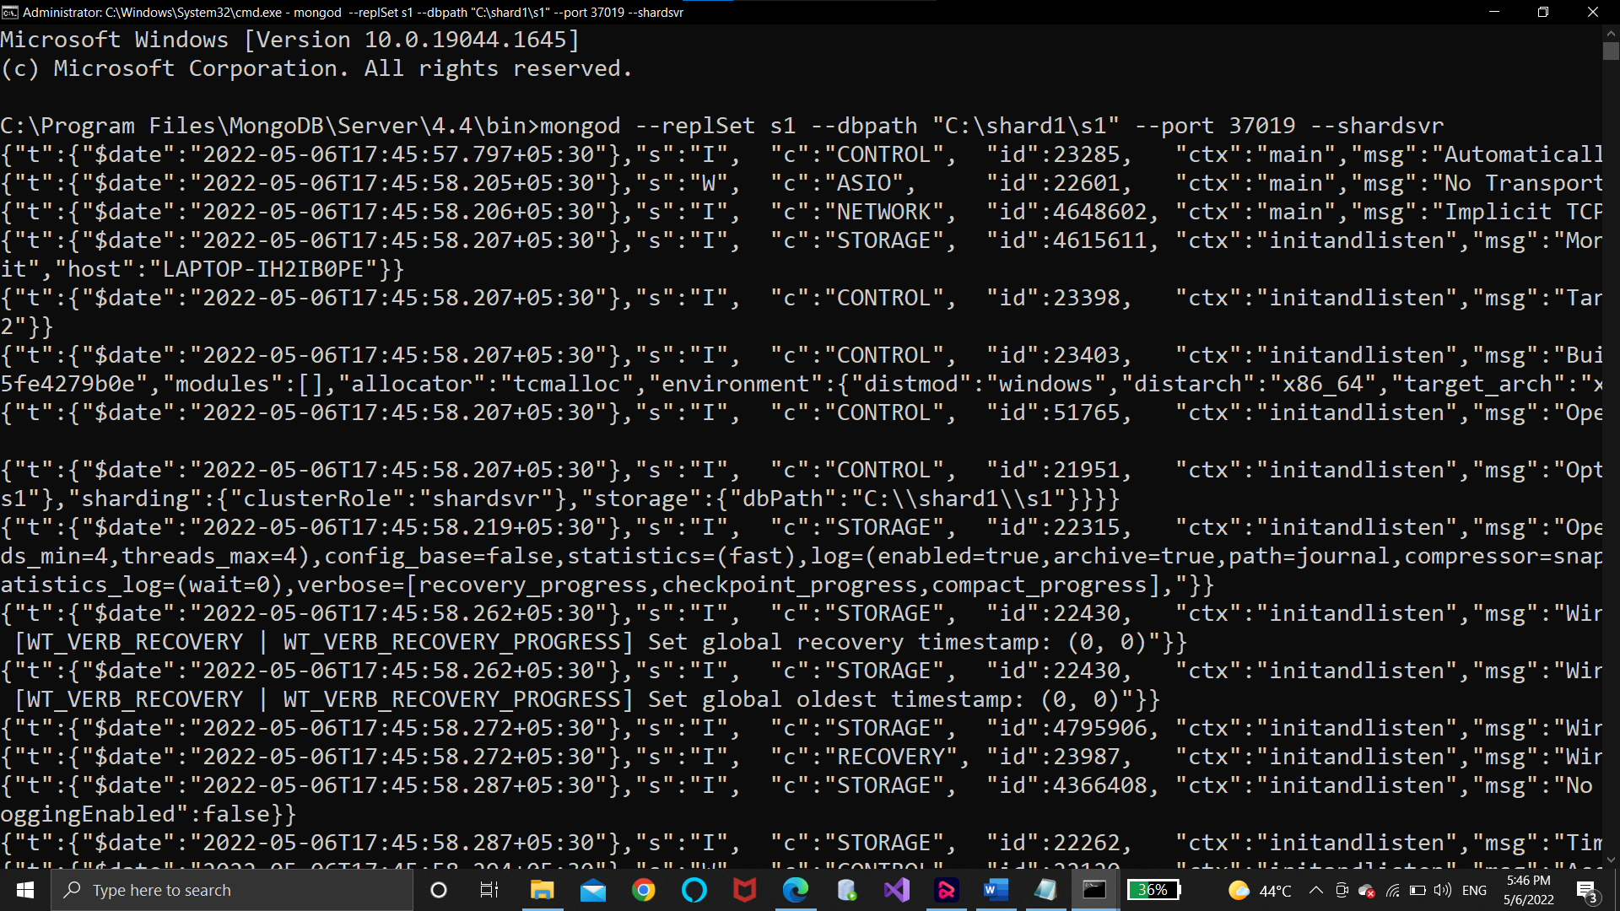

C:\Program Files\MongoDB\Server\4.2\bin>mongod --replSet s1 -- dbpath "C:\shard2\s2" --port 37020 --shardsvr

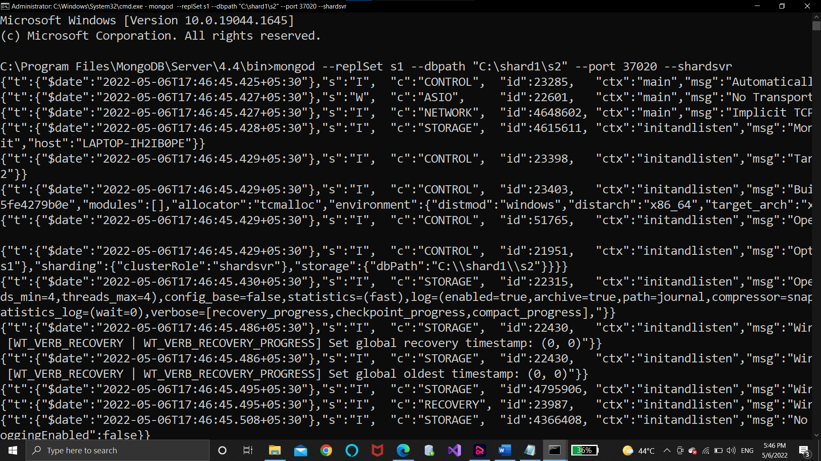

C:\Program Files\MongoDB\Server\4.2\bin>mongod --replSet s1 -- dbpath "C:\shard2\s3" --port 37021 –shardsvr

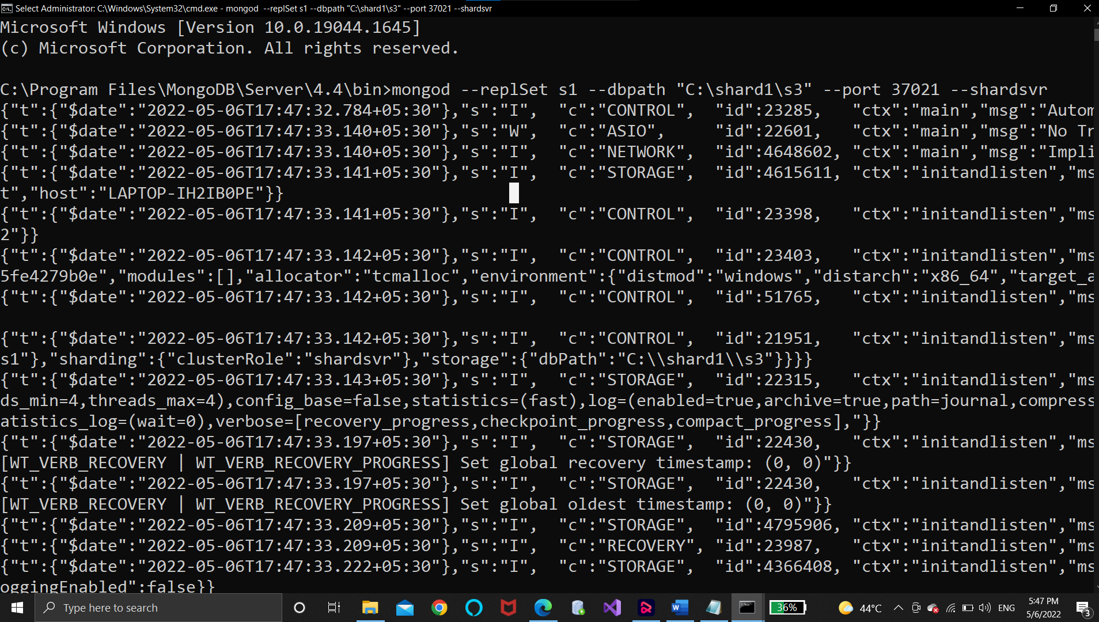

***Now open any mongo client among all and connect with server using below command.***

C:\>mongo --port 37019

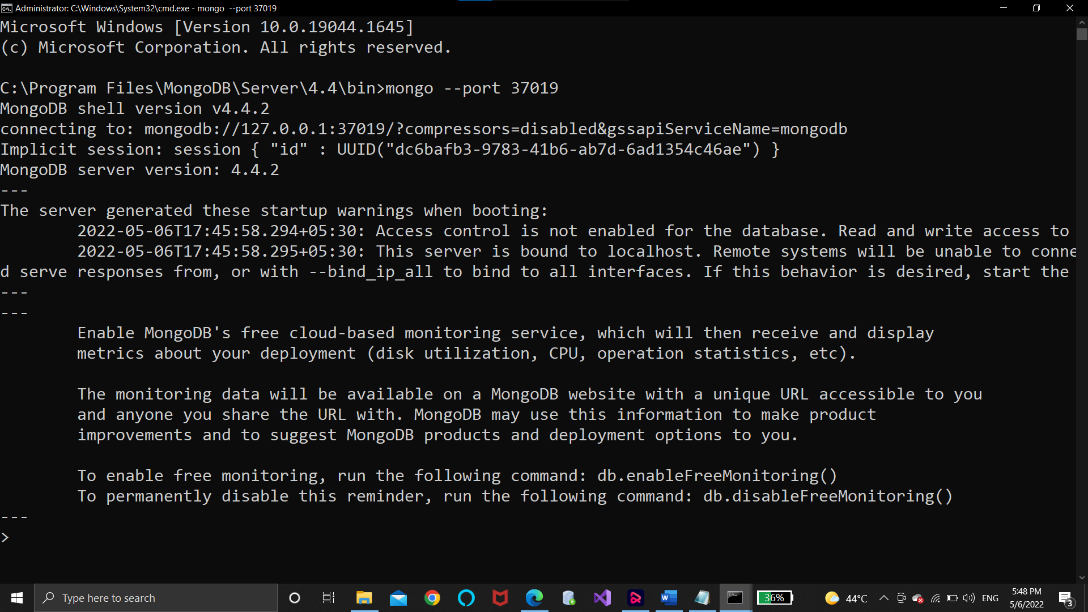

C***reate a group ,assign ids and replica using below command.***

config = { _id: "s1", members:[

{ _id : 0, host : "localhost:37019" }, { _id : 1, host : "localhost:37020" },

{ _id : 2, host : "localhost:37021" }]};

***Set any node as primary node using below given command.***

rs.initiate(config)

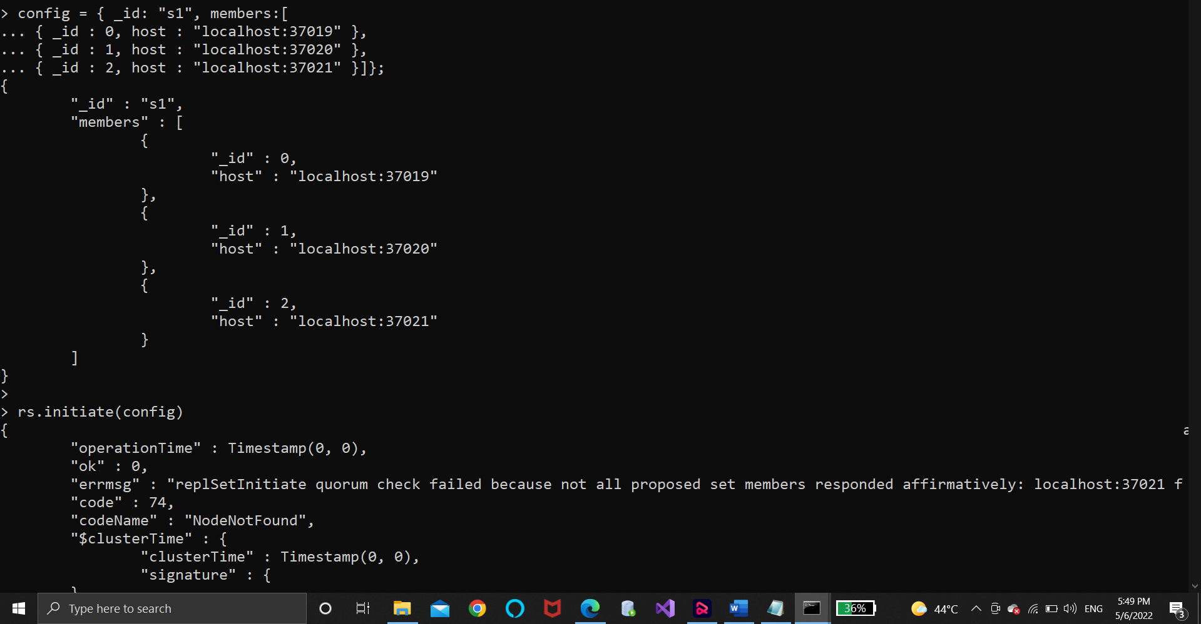

## STEP 6 (SHARD 2)

**OPEN command Prompt.**

**Create three Shard Server. Then Set one shard Server as Primary and remaining two as secondary.**

**Using below commands.**

C:\Program Files\MongoDB\Server\4.2\bin>mongod --replSet s0 --dbpath "C:\shard1\s1" --port 50001 --shardsvr

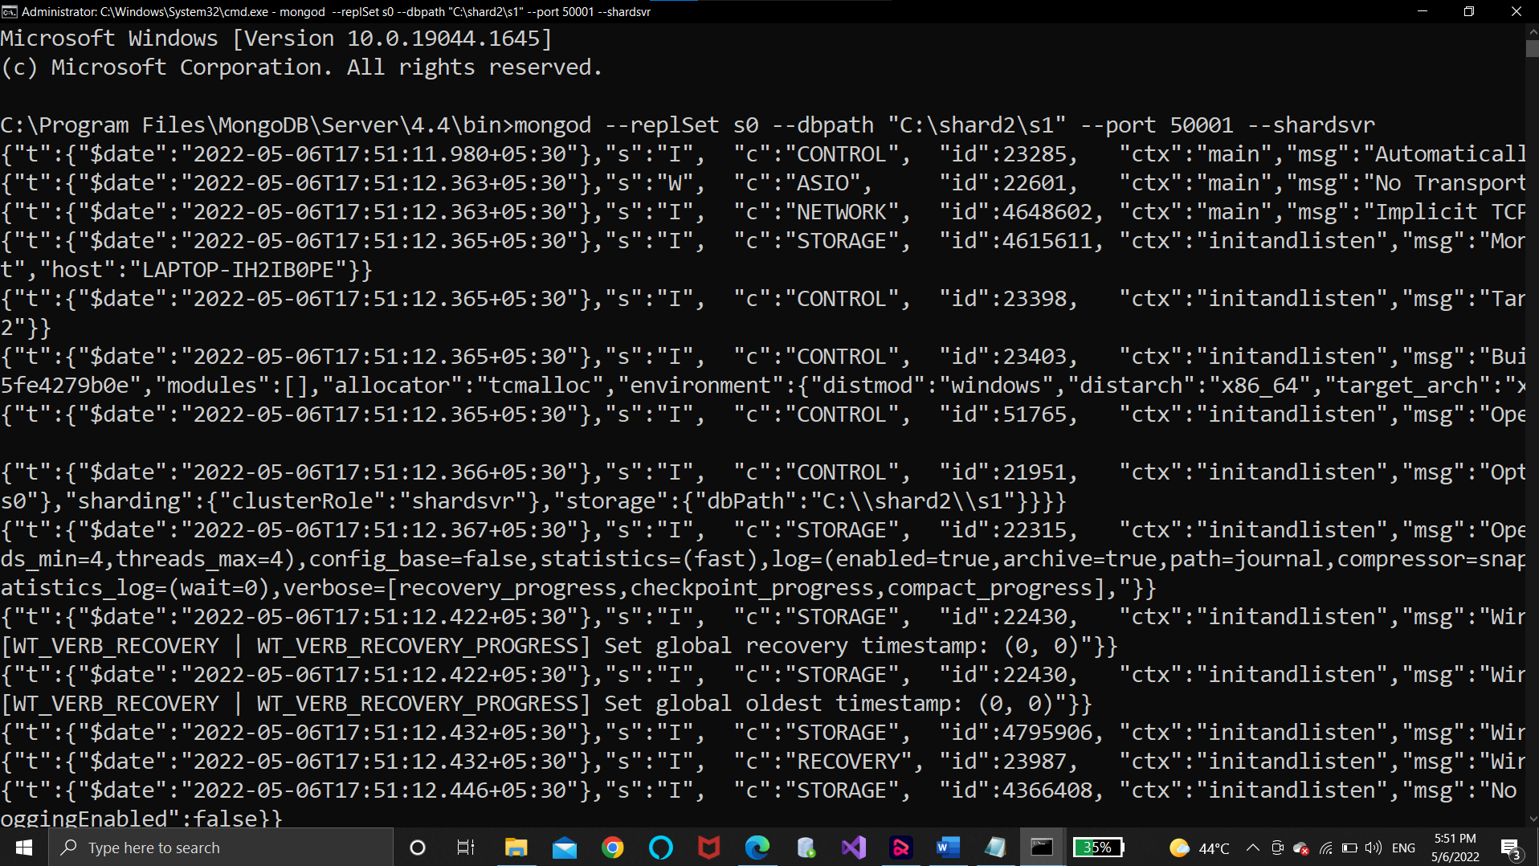

C:\Program Files\MongoDB\Server\4.2\bin>mongod --replSet s0 --dbpath "C:\shard1\s2" --port 50002 --shardsvr

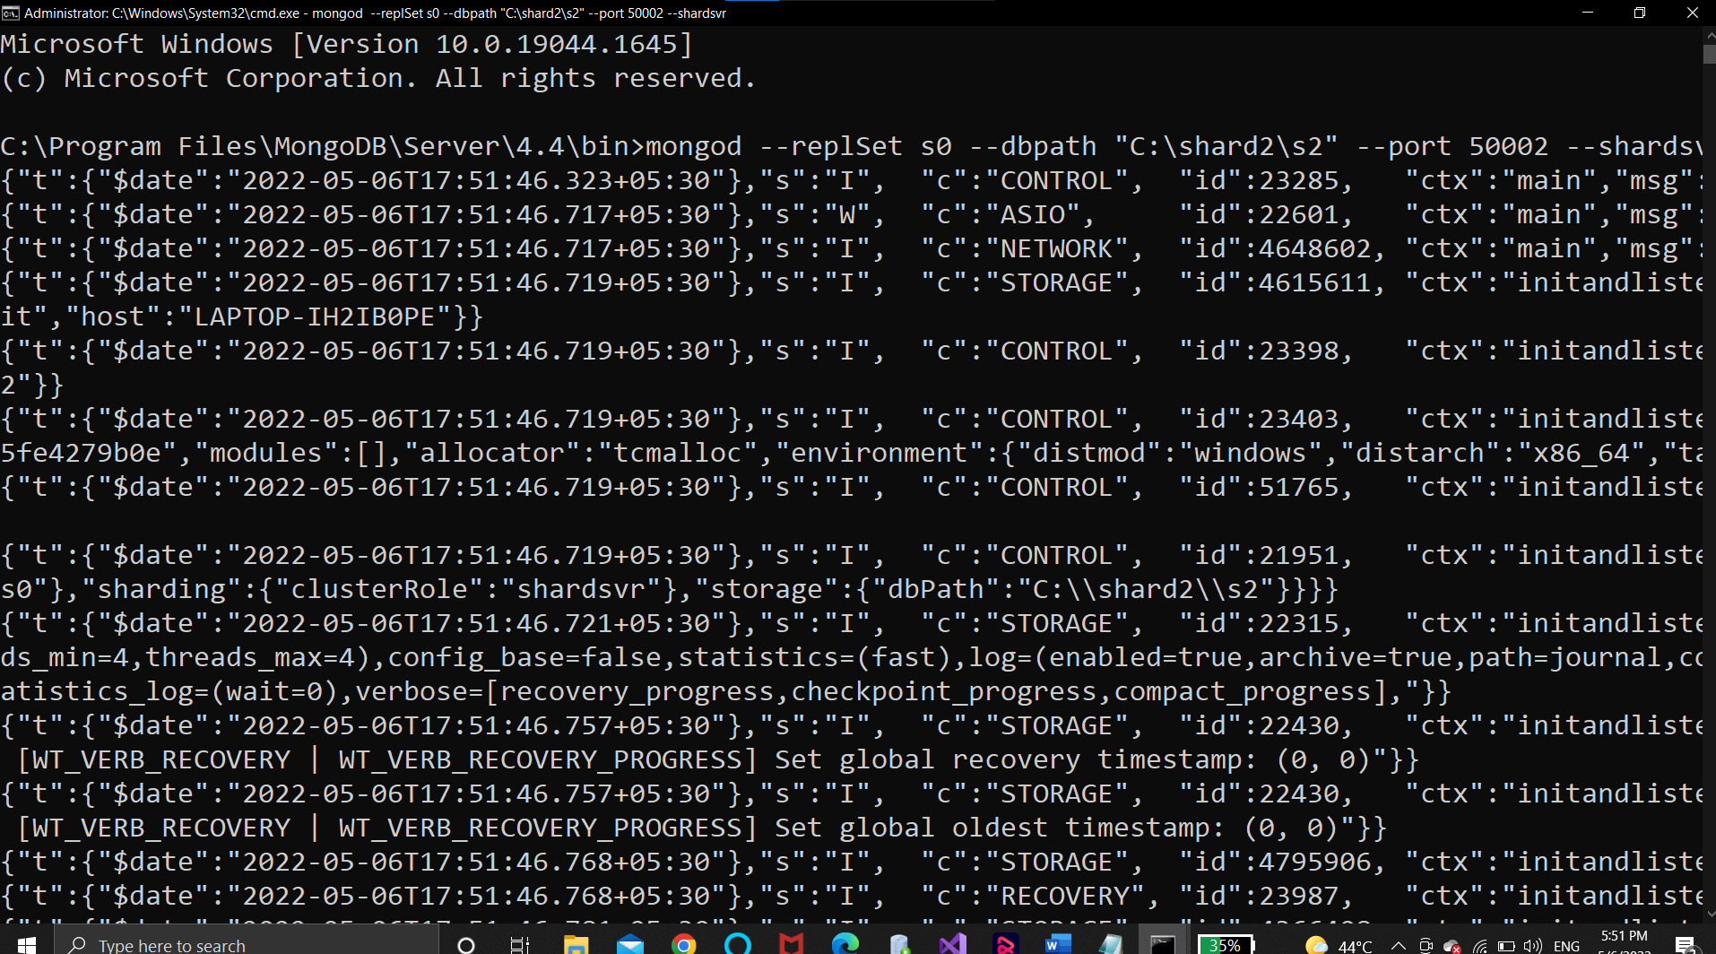

C:\Program Files\MongoDB\Server\4.2\bin>mongod --replSet s0 --dbpath "C:\shard1\s3" --port 50003 --shardsvr

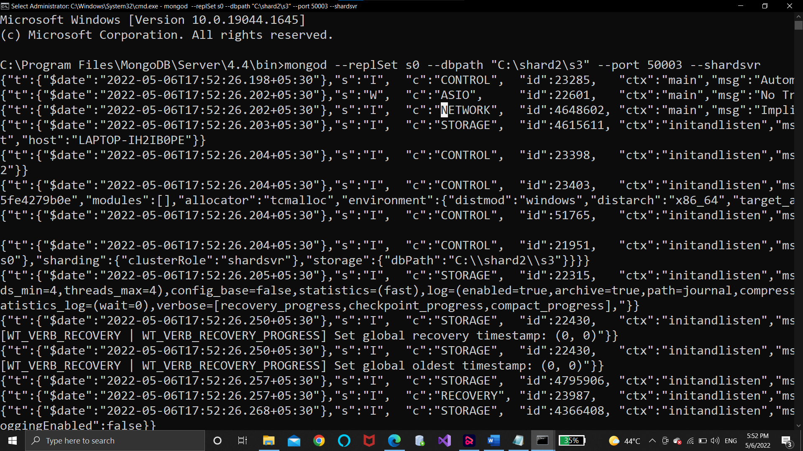

**Now open any mongo client among all and connect with server using below command.**

C:\>mongo --port 50001

Create a group ,assign ids and replica using below command config = { _id: "s0", members:[

{ _id : 0, host : "localhost:50001" },

{ _id : 1, host : "localhost:50002" },

{ _id : 2, host : "localhost:50003" }]};

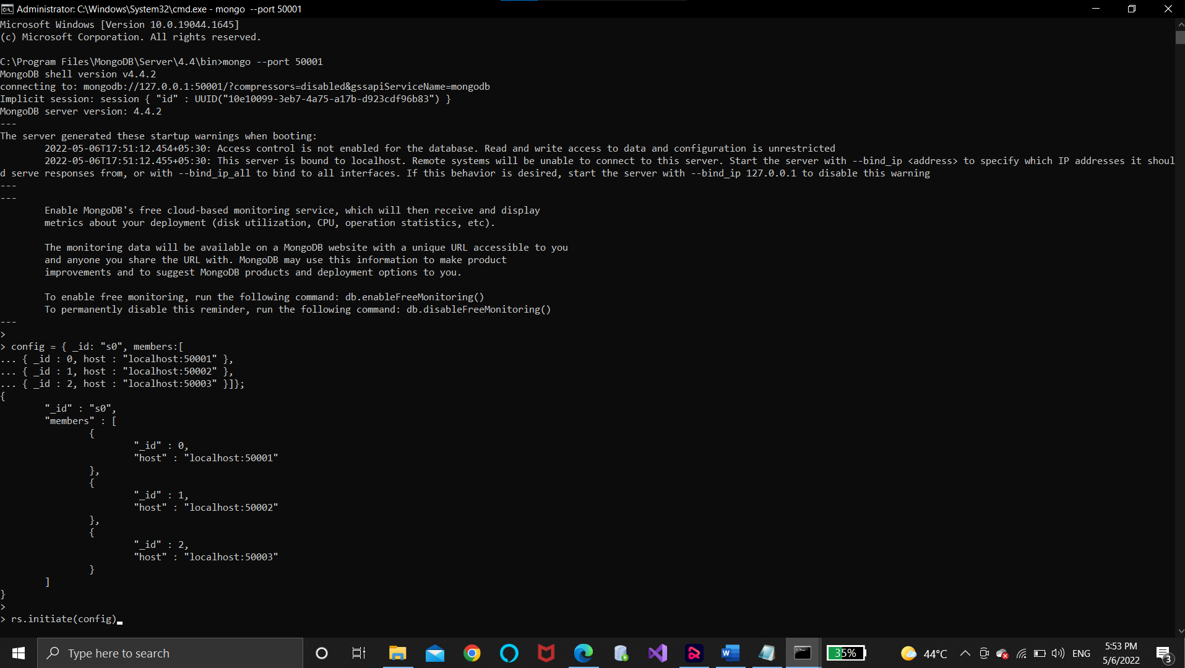

**Set any node as primary node using below given command.**

rs.initiate(config)

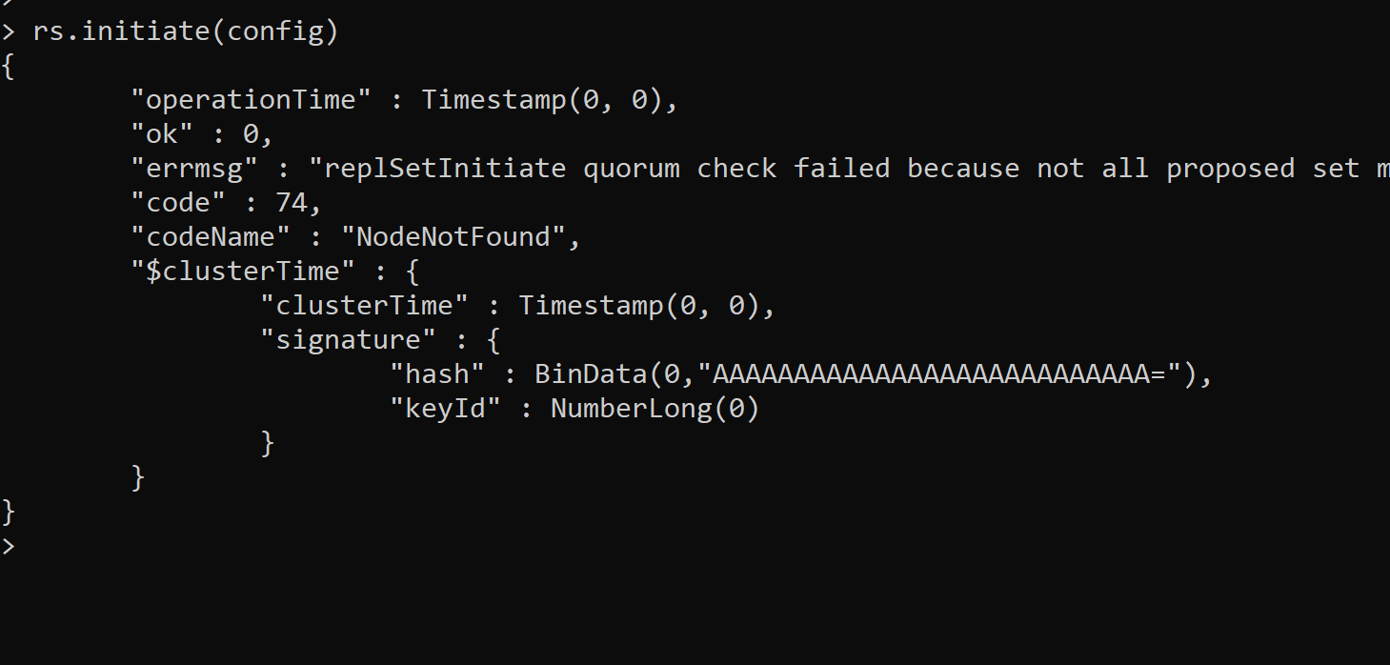

## STEP 7

**Communication with both shards is possible using config servers.**

**So open cmd and write command.This creates mongos config server.**

C:\>mongos.exe --configdb c0/localhost:27018,localhost:27019,localhost:27020 --port 1000 Open a client mongos command window to communicate with server.

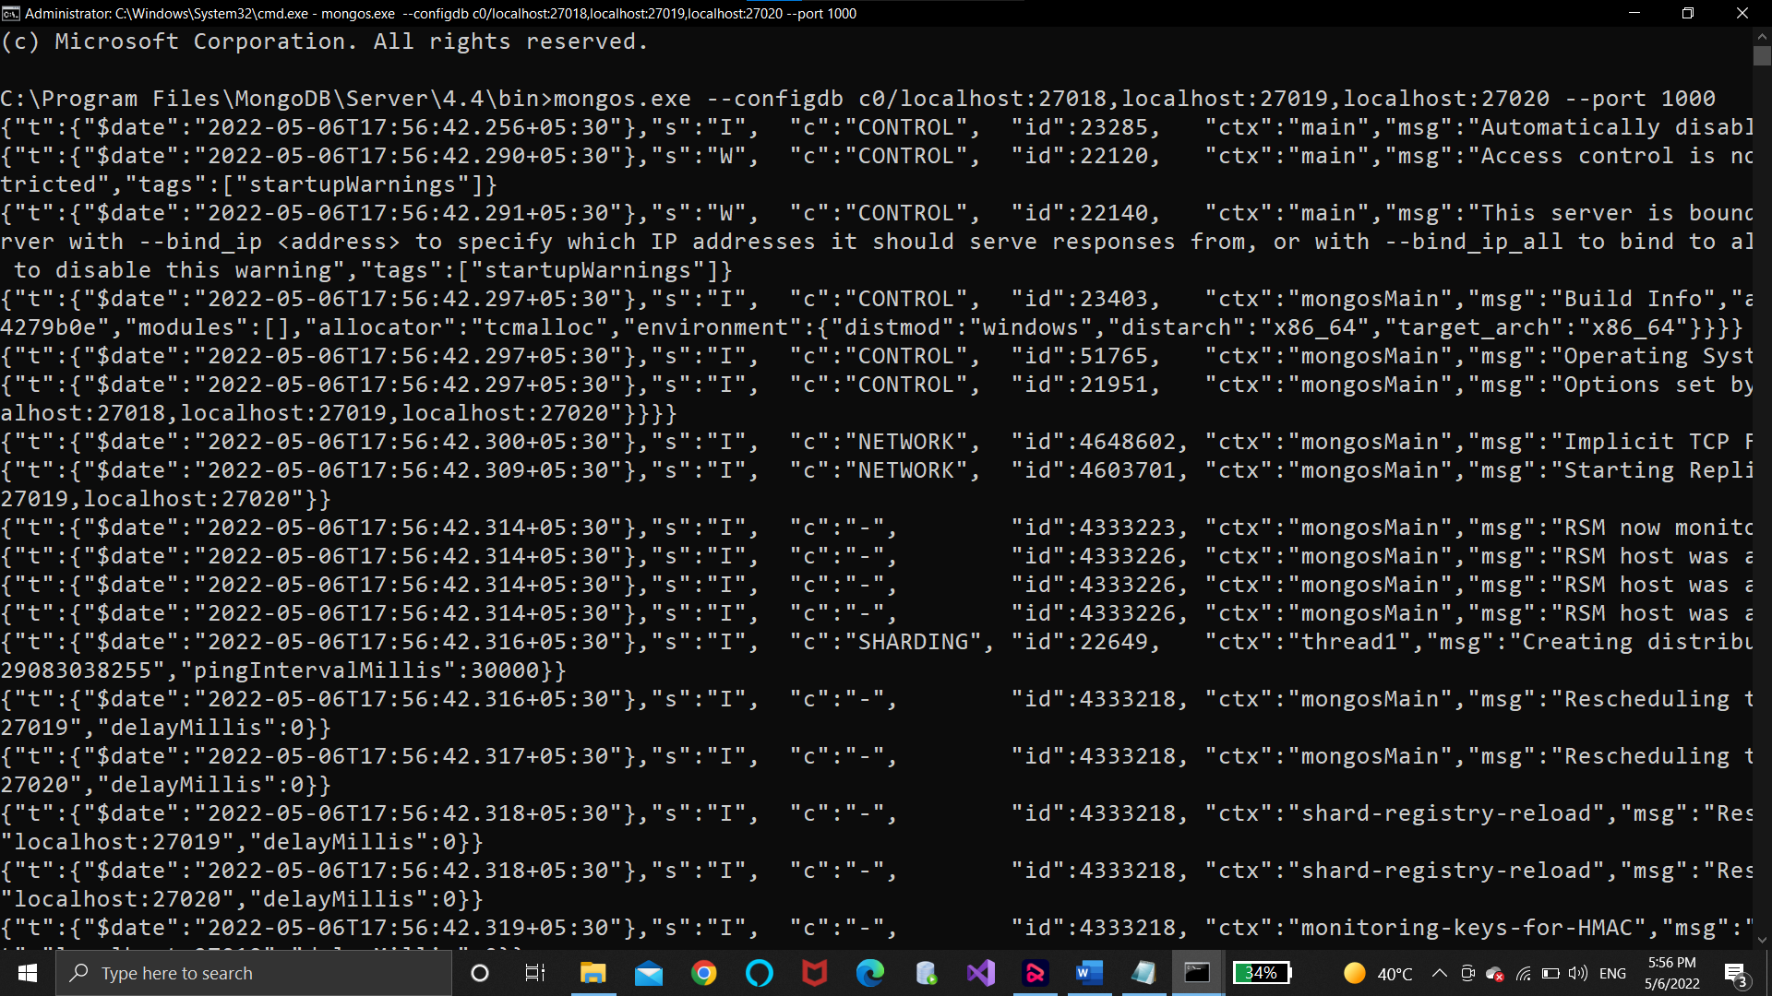

C:\>mongo.exe --host localhost --port 1000

And then both the shards which we are created add that shards into shard cluster using given below commands.

mongos> sh.addShard("s0/localhost:50001"); mongos> sh.addShard("s1/localhost:37019");

## STEP 8

**To see the shards which are in shard cluster run the command in the same command prompt(1000)** db.runCommand({listShards:1});

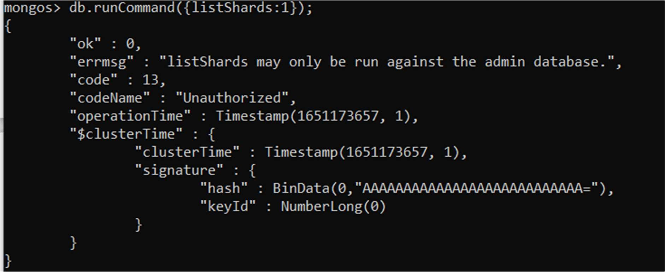

1. **Now create database.**

mongos> use projectionDB switched to db projectionDB

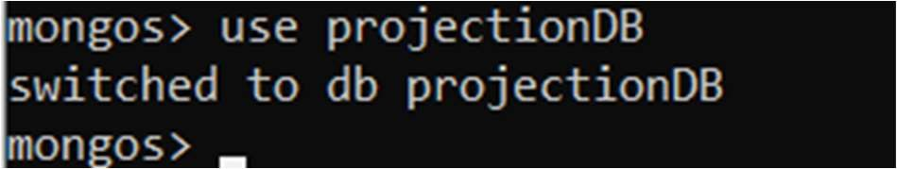

1. **Move to admin mode.** mongos> use admin switched to db admin

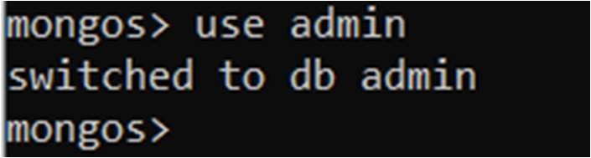

1. **Enable Database Sharding property.So that table data can be distributed on multiple shards using given command.**

mongos> db.runCommand({enableSharding:"projectionDB"});

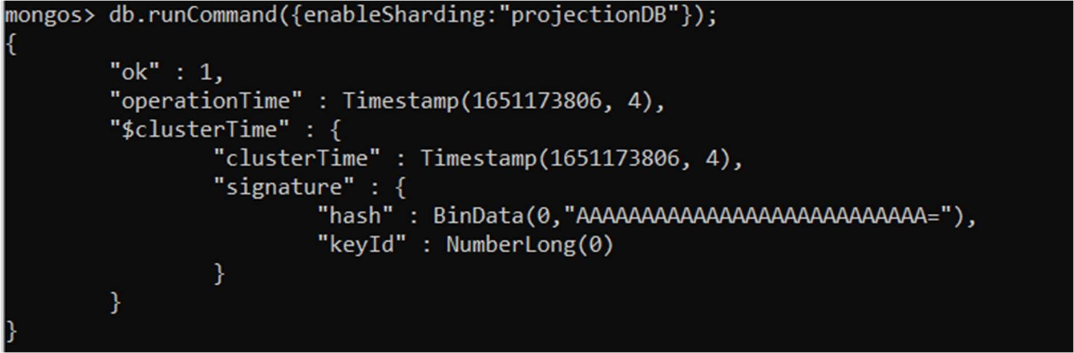

1. **Create collection and set hash key.**

mongos> sh.shardCollection("projectionDB.bios", {"name":"hashed"})

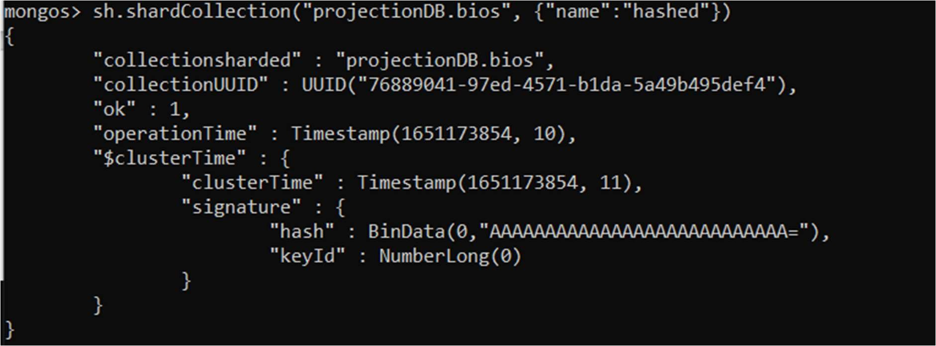

1. **Now insert data into bios table.** mongos> db.bios.insert({

name:"Prachi", lname:"Shah", city:"Mehsana", state:"Gujarat"

});

mongos> db.bios.insert({ name:"sunita", lname:"chauhan", city:"Ahmedabad",

state:"Gujarat" })

mongos> db.bios.insert({

... name:"agam",

... lname:"shah",

... city:"Mehsana",

... state:"Gujarat"

... })

mongos> db.bios.insert({

... name:"Shraddha",

... lname:"Mehta",

... city:"Baroda",

... state:"Gujarat"

... })

mongos> db.bios.insert({ ... name:"Shurya",

... lname:"Pandya",

... city:"Mehsana",

... state:"Gujarat"

... })

mongos> db.bios.insert({

... name:"Khushi",

... lname:"Patel",

... city:"Mehsana",

... state:"Gujarat"

... })

mongos> db.bios.insert({ ... name:"Pooja",

... lname:"Mevada",

... city:"Ahmedabad",

... state:"Gujarat"

... })

mongos> db.bios.insert({ ... name:"Meeta",

... lname:"Shah",

... city:"Ahmedabad",

... state:"Gujarat"

... })

mongos> db.bios.insert({ ... name:"Avinash",

... lname:"Mehta",

... city:"Ahmedabad",

... state:"Gujarat"

... })

mongos> db.bios.insert({ ... name:"Vency",

... lname:"Parekh",

... city:"Ahmedabad",

... state:"Gujarat"

... })

mongos> db.bios.insert({ ... name:"Dhruv",

... lname:"Shah",

... city:"Ahmedabad",

... state:"Gujarat"

... })

Run the command to see the total number of documents in bios table.

db.gnu.count();

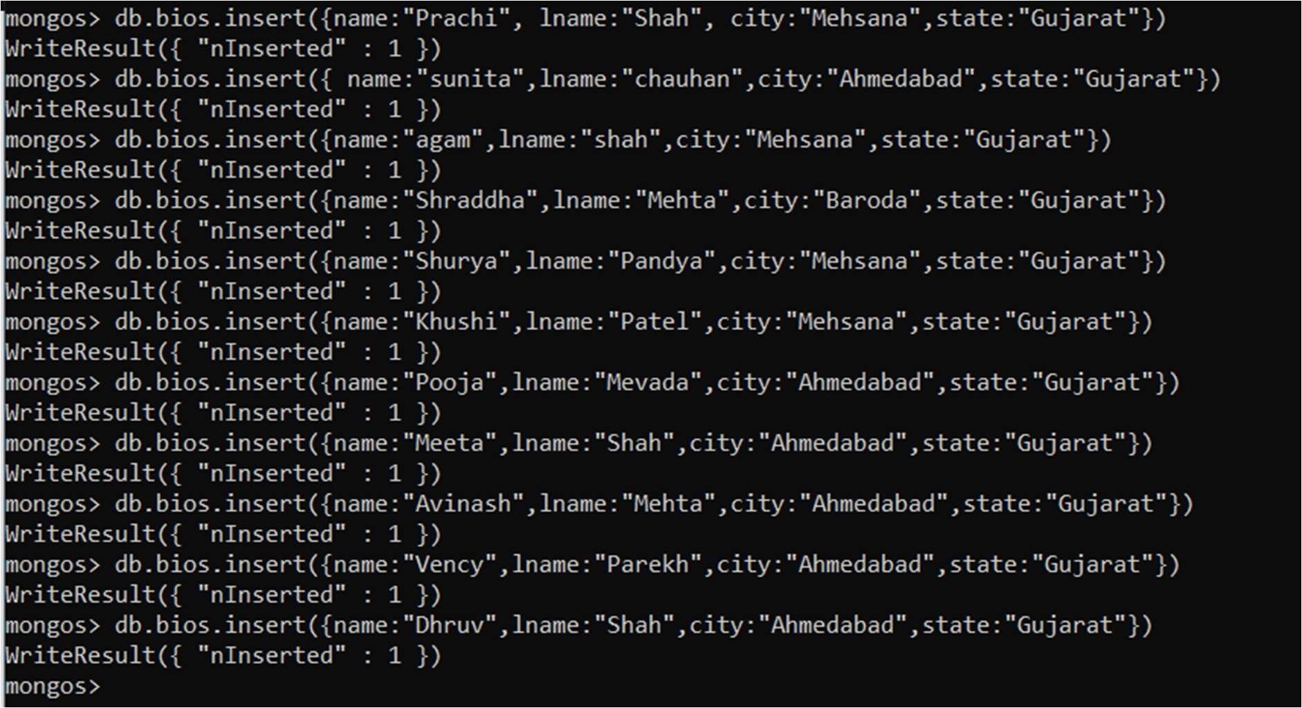

## STEP 9

**To see how data is distributed on shard 1.**

**Open the mongo client of shard 1 which is on port 50001.**

Run the commands like.

Show dbs Show

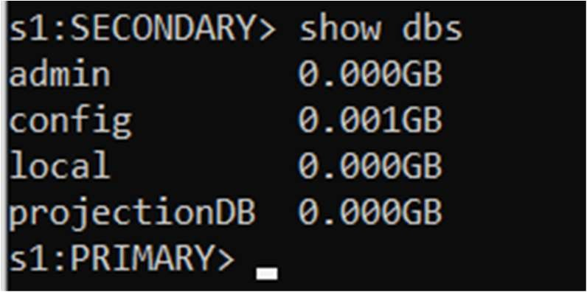collection use

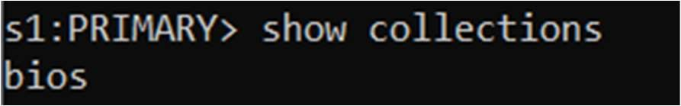projectionDB;

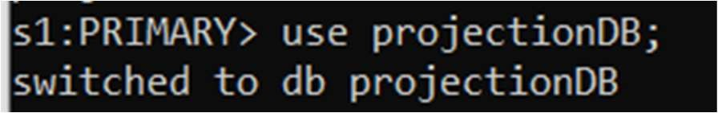db.bios.count();

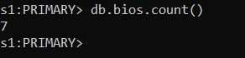

## STEP 10

**To see how data is distributed on shard 2.**

**Open the mongo client of shard 2 which is on port 37019.**

**Run the commands like.**

Show dbs Show

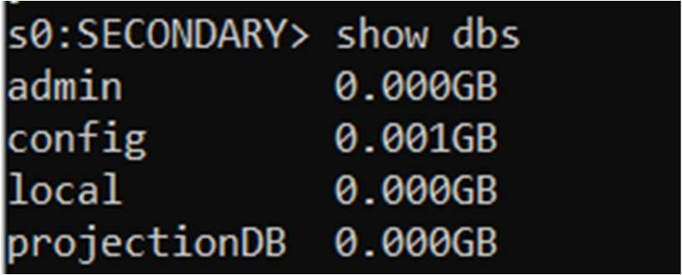

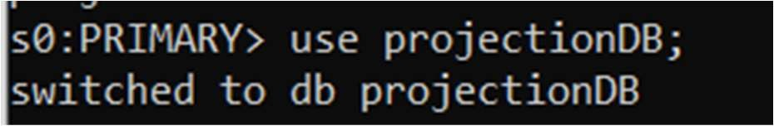db.bios.count();

